**Lesson 1 Introducing WonderCam**

# Instructions

WonderCam is an user-friendly AI visual module with eight built-in functions: Color Recognition, Facial Recognition, AprilTag Recognition, Visual Line Following, Numeric Recognition, Landmark Recognition, Image Classification and Feature Learning.

WonderCam make learning AI fun and easy to comprehend. With 1-Click Training feature, it can readily program many creative AI visual projects.

WonderCam IIC connector works seamlessly with many global leading controllers like micro:bit, Arduino, Raspberry Pi etc. By sending the recognized result output to the controller, you can focus on project creativity without the programming complexity.

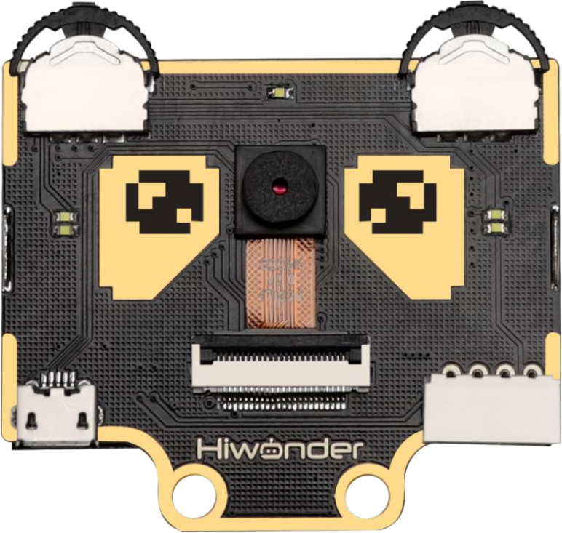

# Operation Overview

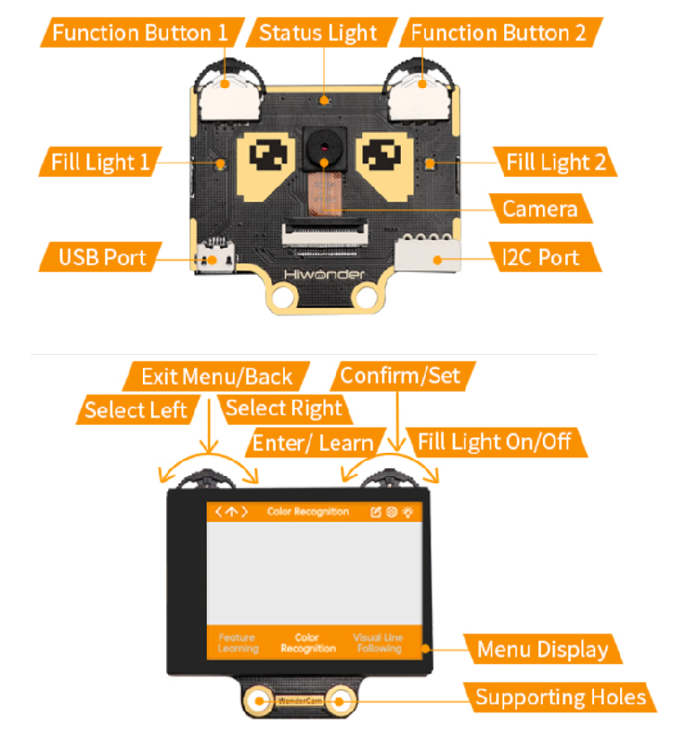

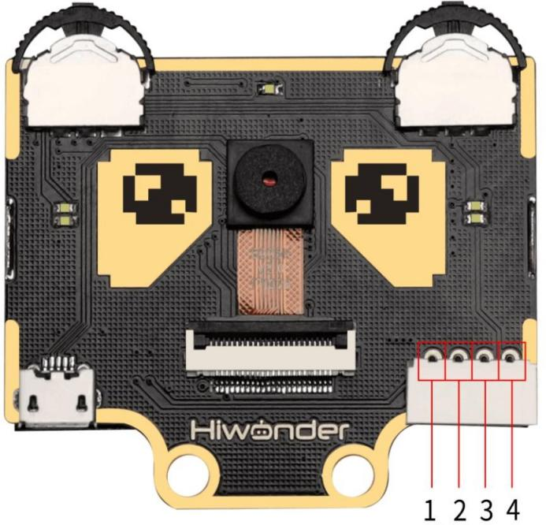

**IIC Connectors Specification**

|  |  |  |
| --- | --- | --- |
| S/N | Name | Function |
| 1 | SCL | IIC Serial Clock Pin |
| 2 | SDA | IIC Serial Data Pin |
| 3 | GND | IIC Negative Pin |
| 4 | 5V | 5V Positive Pin |

# User Learning Guideline

Step 1: Understanding WonderCam module and operating familiarization

Start with "Lesson 1 Introducing WonderCam" follow by "Lesson 2

Getting Started".

Step 2: Step by Step guide to AI Visual Module features and functions

The 8 lessons are: Color Recognition, Facial Recognition, AprilTag Recognition, Visual Line Following, Numeric Recognition, Road Sign Recognition, Image Classification and Feature Learning.

Step 3: Learn as needed

Upon experiencing all the features and functions, learner can further explore programming each features with the guideline provided for different platform.